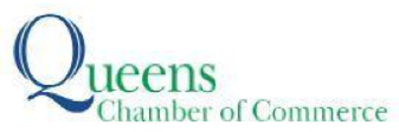

Contact: Lauren Braithwaite,
lauren@anatgerstein.com, (347) 361-7183

For Immediate Release

QUEENS CHAMBER OF COMMERCE AND HUNDREDS OF BUSINESS LEADERS VISIT THE STATE CAPITOL FOR QUEENS DAY IN ALBANY

The Queens Chamber also held a “A Taste of Queens” reception featuring dozens of eateries

For photos, click here (Credit: Joseph Connor)

QUEENS, NY (May 8, 2026)—Hundreds of business leaders from across Queens traveled to Albany on May 5 to meet with state lawmakers and advocate for the borough’s economic future as part of the Queens Chamber of Commerce’s annual Queens Day in Albany. The daylong event brought together entrepreneurs, industry leaders, and policymakers for a powerful show of unity and engagement at the State Capitol.

Chamber members met with dozens of State Senate and Assembly representatives to discuss key priorities from the Chamber’s 2026 Legislative Agenda, focusing on expanding economic opportunities, strengthening the local workforce, and making it easier for small businesses to grow and thrive.

“Showing up in Albany and having real conversations with our elected officials is how we move the needle for Queens businesses,” said Tom Grech, President and CEO of the Queens Chamber of Commerce. “We talked about key priorities like bringing new economic opportunities to Queens, supporting our local workforce, and making it easier for businesses to grow and succeed. I’m proud of the strong turnout from our business community and grateful to the legislators and their teams for taking the time to listen and engage.”

The day culminated in a high-energy “Taste of Queens” reception that celebrated the borough’s unmatched diversity and cultural vibrancy. The event featured more than 40 Queens restaurants and 10 cultural organizations, alongside special appearances by Mr. and Mrs. Met, MLB legend and Hall of Famer Carlos Beltrán, and New York City Football Club mascot Sky Scraper. Hip hop pioneer Ralph McDaniels served as special guest DJ, bringing an iconic Queens soundtrack to the evening.

Queens Day in Albany continues to serve as a vital platform for amplifying the voices of the borough’s business community while highlighting the energy, talent, and diversity that make Queens a driving force in New York’s economy.
About the Queens Chamber of Commerce:
The Queens Chamber of Commerce is the oldest and largest business association in Queens, representing more than 1,400 businesses and more than 150,000 Queens-based employees. Its mission is to foster connections, educate for success, develop/implement programs and advocate for members’ interests. www.queenschamber.org
###

